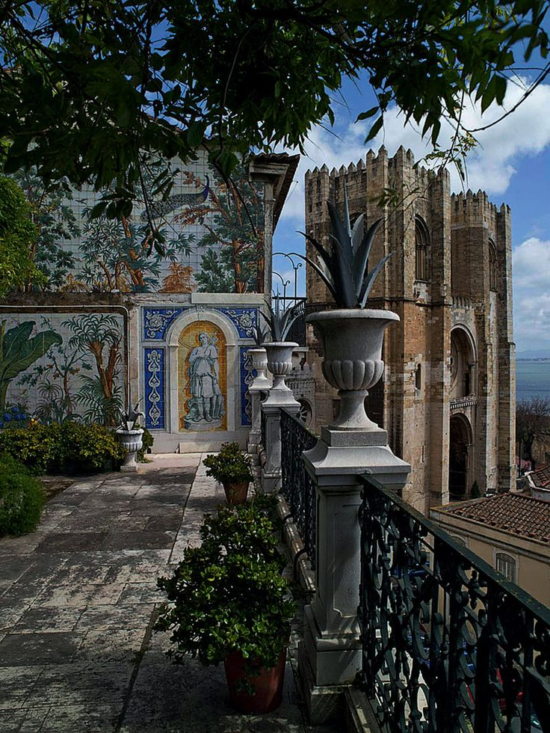

**Lisbon**

Lisbon, capital city of Portugal has been ranked as one of the loveliest European capitals and surely one of the most affordable . This both colourfuland cosmopolitan city has kept intact its charms of the old days and the impressive monuments reminding the by-gone glories and imperial power.

|  |  |
| --- | --- |
| **Day 1 – Lisbon** |  |

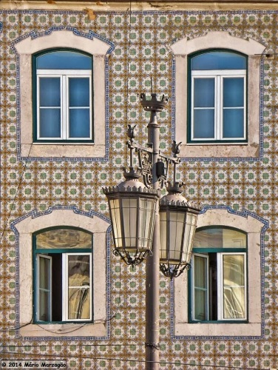

Arrival at Lisbon Airport and meet our assistant who will transfer you to the hotel of your choice where you will stay for next three nights.

Dinner and overnight in the selected hotel

|  |  |
| --- | --- |
| **Day 2 – Lisbon** |  |

Our guide will unveil for you the secrets of Lisbon: Besides the Heritage World Monuments like Jerónimos Monastery or the Tower of Belém, you will get acquainted with the cobbled narrrow streets and steep causeways of the old Medieval quarters of Alfama and the Castle hill.

Experience a gourmet lunch with a codfish menu ( cooked in four different ways) that will marvel your palate with the exquisite taste of the Portuguese genuine cuisine.

Afternoon can be spent in a photo safari in the old town – prizes and awards to the best photographers, or cruising two hours in the Tagus river.

[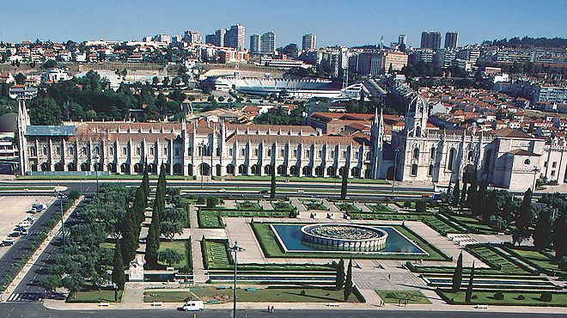](https://www.google.pt/url?sa=i&rct=j&q=&esrc=s&source=images&cd=&cad=rja&uact=8&ved=0ahUKEwi4hvrvlI7LAhWFQBoKHW3QDsEQjRwIBw&url=https%3A%2F%2Fwww.visitportugal.com%2Fpt-pt%2FNR%2Fexeres%2FED2700C2-0CC6-46E4-B5AA-C3C5A9CE2EF2&psig=AFQjCNHbCk2o7j4tQyibyJ-9IUS-BnxuLA&ust=1456326411080561)Dinner and overnight in the selected hotel

|  |  |
| --- | --- |
| **Day 3 – Lisbon and the sunny coast Estoril / Cascais & Sintra** |  |

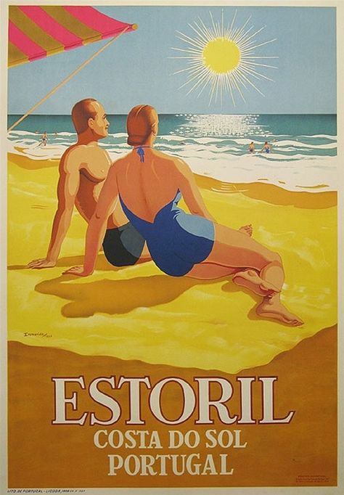

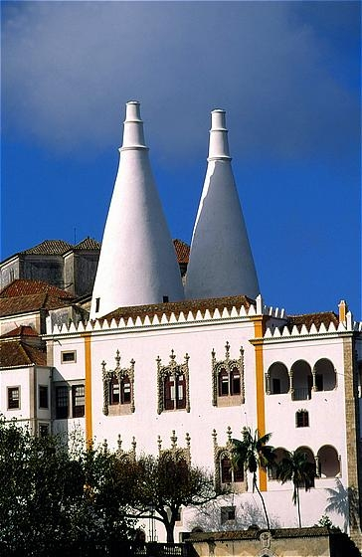

Full day excursion with typical lunch included.

You leave Lisbon towards Sintra, Summer residence of the Portuguese kings since the Middle Age,visit the Royal Palace its richly decorated rooms and the huge kitchen topped by the gigantic conic chimneys.

Enjoy a truly Portuguese lunch

After lunch drive through the wooded hills of Sintra till Capo da Roca, the westernmost point of the Continental Europe.

A certificate of presence in this geographical landmark with your name on tit can be issued (need to be preordered to avois queus)

( this tour can be made in fwd jeeps taking off beaten tracks)

Return to Lisbon will follow the coastal road through the seaside resorts of Cascais and Estoril..

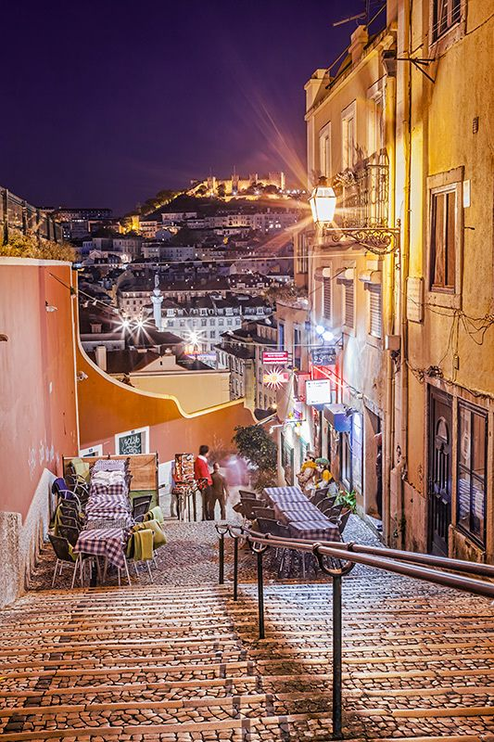Options for dinner.

A dinner in a typical restaurant with fado singing

A dinner in a top-class restaurant with a special menu

Or on your own exploring thedowntown small restaurants. Overnight in the selected hotel.

[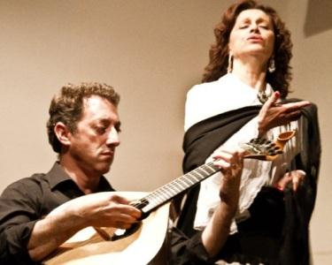](https://www.google.pt/url?sa=i&rct=j&q=&esrc=s&source=images&cd=&cad=rja&uact=8&ved=&url=http%3A%2F%2Fforretas.com%2Fdescontos%2Fodisseias%2Fpateo-alfama-2-jantar-fado%2F1035444&psig=AFQjCNEcLC3evcT01XZQtxgyVKuRvyD5Lg&ust=1456326778284539)

|  |  |
| --- | --- |
| **Day 4 – Lisbon** |  |

Transfer to Lisbon airport and end of our services

